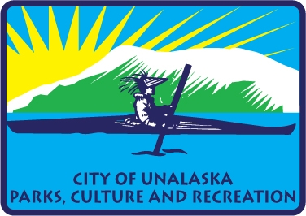

**City of Unalaska | Department of Parks, Culture and Recreation**

**Advisory Committee Meeting Minutes for September 9, 2024**

Members present: Thomas Roufos, Greg Peters, Ben Knowles, Jill Spetz, Ryan Humphrey

The Parks, Culture and Recreation Advisory Board Meeting was called to order at 5:30 p.m. on September 9, 2024, in the conference room at PCR

Recognized visitors to the meeting, Jolene Longo, Jeffery Milkes

**New Business**

The Advisory Board had a presentation from Jeffery Milkes of Berry Dunn and associates on the master plan process and the different sections of the plan. (See Attached) The plan is moving along on schedule and at the next meeting in October the Advisory Board should have a first completed draft plan to look at.

**Old Business**

Jolene said that before the winter season that additional soil and seed would need to be placed at Kelty Field. Additional infield mix needs to be purchased.

**Committee Members Comments**

Greg asked if the City had applied for the brown fields grant for the multi-use facility. Thomas explained that the City had not applied for the grants at this time, and that the brownfields grant might not be the best place to look for the money to build the multi-use facility. We should look at FEMA to help with the building. The City is in the process of hiring a grants writer and they would be starting on the 16th of the month.

Ben said the Adult Soft Ball season went great but that field work was desperately needed. More grass on the out field and infield mix was needed for the infield. He also said that the bases needed to be realigned and that was going to take some extra coordination. Some of the work could be done by volunteers but some of the work needed to be done by the City. Next year they were thinking of having a 4th of July start of the season. The Softball Adult League volunteers had also put in electrical conduit to the pitcher mound in order to have a pitching machine for Little League. Little League would be playing on Saturday and Adult soft ball would be on Sundays next year.

Ben asked who maintains the fire alarm box at the pool? It is a relay box but that It is not working properly and needs some maintenance.

The Men’s locker room at the pool needs to be clean better. Even though the school janitorial service has been lacking due to the illness of the person assigned to the building the men’s locker room needs attention. Roger said that he would get on it and put extra shifts to clean the locker room.

Roger talked to the group about the PAC desire to pick up some of the programs from the Arts Council, one of the things we are looking at doing is a coffee house program on the 26, of September. Jill said that other non-prophets were also considering doing a version of the coffee house.

**Next meeting is October 21, 2024.**

**Adjournment at 6:41 p.m.**