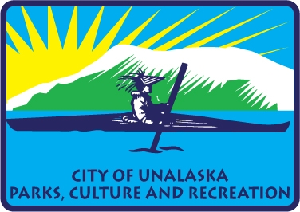

**City of Unalaska | Department of Parks, Culture and Recreation**

**Advisory Committee Meeting Minutes for May 20, 2024**

Members present: Thomas Roufos, Ben Knowles, Jill Spetz, Ryan Humphrey

The Parks, Culture and Recreation Advisory Board Meeting was called to order at 5:40 p.m. on May 20, 2024, in the conference room at PCR

Recognized visitors to the meeting, Jolene Longo

**New Business**

The Advisory Board reviewed the minutes of April 15, 2024, and, it was a unanimous vote to approve.

Roger and Jolene presented the draft Parks and Recreation survey form, produced by Berry Dunn an explained that this survey would be mailed to every home, it would also have an internet survey connection, and had a QR code that you would be able to access the on-line survey. Jolene had already given out a youth survey to the school.

There would also be a $500.00 gift card drawing for people that fill out the survey and enter their address and phone number. Jolene is also going to promote the survey on all of our social media.

The Parks and Recreation Advisory Board believed that the survey was good, but would like the font changed to make it more readable.

Jolene, made a presentation on the fee schedule and explained the changes this year. Jolene explained that most of the changes were to make everything line up across the board. She also added Kelty Field concession stand in the rental schedule. Aquatic center mezzanine changed the rate to incorporate the fee for children swimming. Rather than charging the party a separate fee.

On August 17, 2024, will be the last meeting with Berry Dunn at the HOA event and we should be seeing the backbone of the plan developing. The plan should also outline a good CMMP plan.

**Old Business**

Jolene said that the grass seeding at Kelty Field would be done soon due to the weather having a nighttime temperature over 32 degrees at night. The field will be ready for play by July 20th 2024.

The infield mix will be delivered next Friday.

Pool Roof inspection took place on May, 20 2024.

**Committee Members Comments**

**Next meeting is September 9, 2024.**

**Adjournment at 6:11 p.m.**